|  |  |
| --- | --- |
| PROJECT REPORT  Inventory Management System | Abstract  The inventory management System mainly for inventory manager use. |

**Contents**

PROJECT LINK 2

TECHNOLOGYUSED 2

TEAM MEMBERS 2

INTRODUCTION TO INVENTORY MANAGEMENT SYSTEM 3

Home Page 4

Products page 4

Orders Page 5

Forms Page 6

# PROJECT LINK

<https://github.com/Usman173/ims-db>

# TECHNOLOGYUSED

* NextJS13
* Javascript
* TailwindCSS
* MySQL Database
* Rest APIs

# TEAM MEMBERS

1. M. Usman - cs211140
2. Raahim Shah - cs211105
3. Aman Imran - cs211249

# INTRODUCTION TO INVENTORY MANAGEMENT SYSTEM

The Next.js 13-based Inventory Management System is a comprehensive solution designed to streamline and optimize your inventory management processes. Leveraging the power of JavaScript, Tailwind CSS, and a MySQL database, our website offers a user-friendly interface with a range of functionalities including CRUD operations. With our system, you can easily add, delete, update, and retrieve products, empowering you to stay in control of your inventory at all times. Moreover, our platform allows you to manage customer information, enabling seamless communication and personalized experiences. You can efficiently create orders. Our system also facilitates categorization of products and tracks the suppliers associated with each product, enhancing organization and simplifying procurement processes. Experience the efficiency and convenience of our Inventory Management System as it empowers you to optimize your operations and achieve better control over your inventory.

ENTITY RELATIONSHIP DIAGRAM

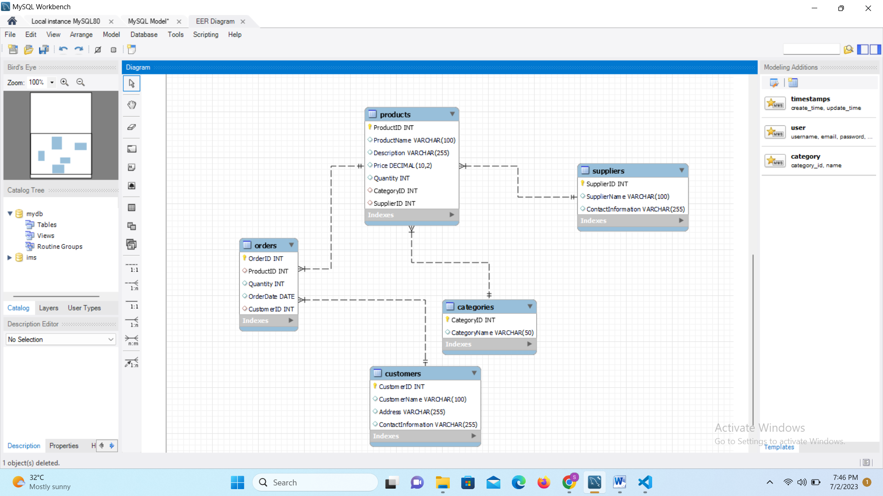

Flow of Project

This inventory management system has various functionalities for inventory admin’s convenience. Following are the pages.

* Home page
* Products page
* Orders page
* Forms page

1. Add product
2. Update product
3. Add customer / Place order

## Home Page

The home page serves as the initial introduction to the website, featuring the inventory logo and a navigation bar that provides access to various pages. The main section of the home page displays small cards that serve as links to different pages, allowing users to easily navigate through the website.

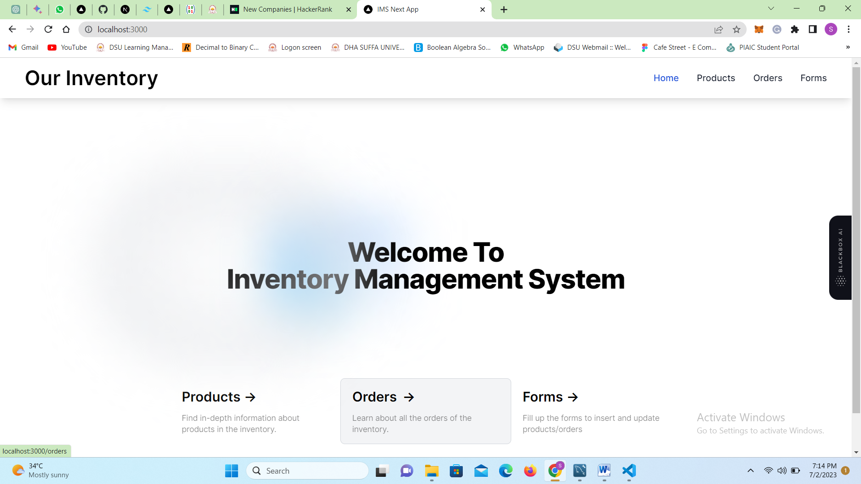

## Products page

The product page provides users with comprehensive product details, including information such as product name, price, quantity, suppliers, and category. Additionally, users have the capability to remove products from the page as long as they have not been ordered yet.

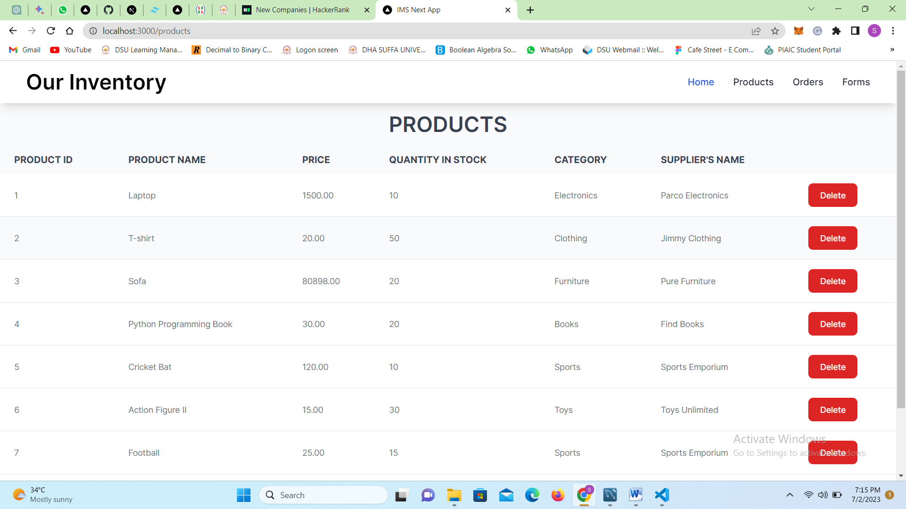

## Orders Page

The orders page displays a comprehensive view of all the orders placed within the inventory, presenting detailed order information such as customer ID, product ID, quantity, and the total amount for each product ordered.

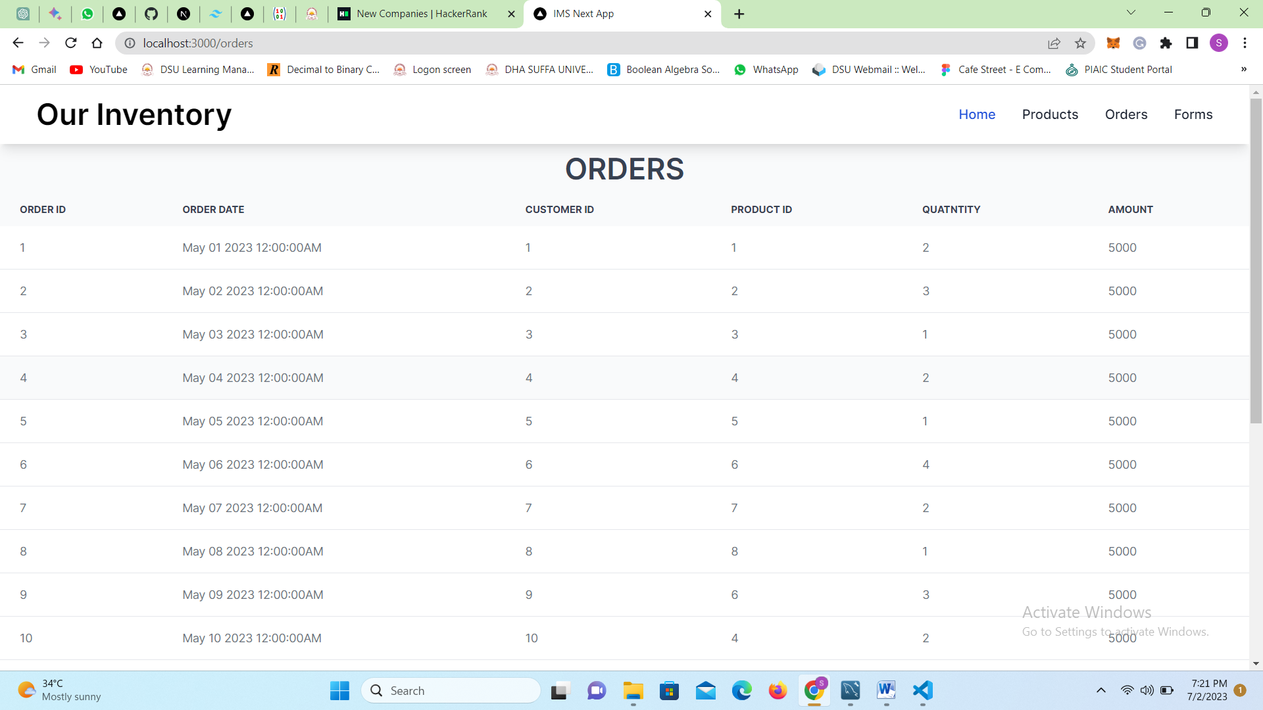

## Forms Page

This page offers three distinct options for users to choose from: adding a product, updating a product, and placing orders.

* Add Product Form

The "Adding Product" form component is utilized within the forms page. It allows users to insert a new product record into the database table. All fields in the form must be filled with valid data types. Upon submitting the form, a popup will be displayed to indicate the successful insertion of the product.

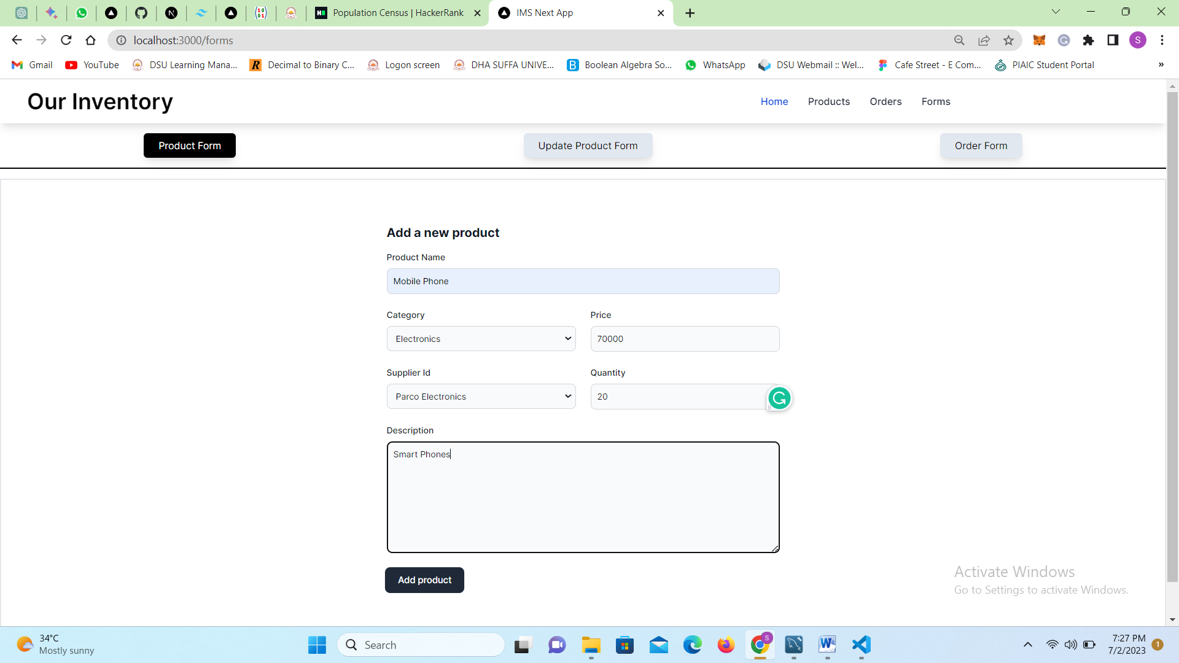

* Update Product Form

The update product form component is utilized in both the forms page and the update product page. This form enables the modification of a specific product record in our database table. Initially, the form prompts the user to search for the product to be updated by submitting its ID. Upon submission, if the record is found, its details will populate the form, allowing the user to update all fields except for the category and suppliers. Upon submitting the form, the corresponding record will be successfully updated.

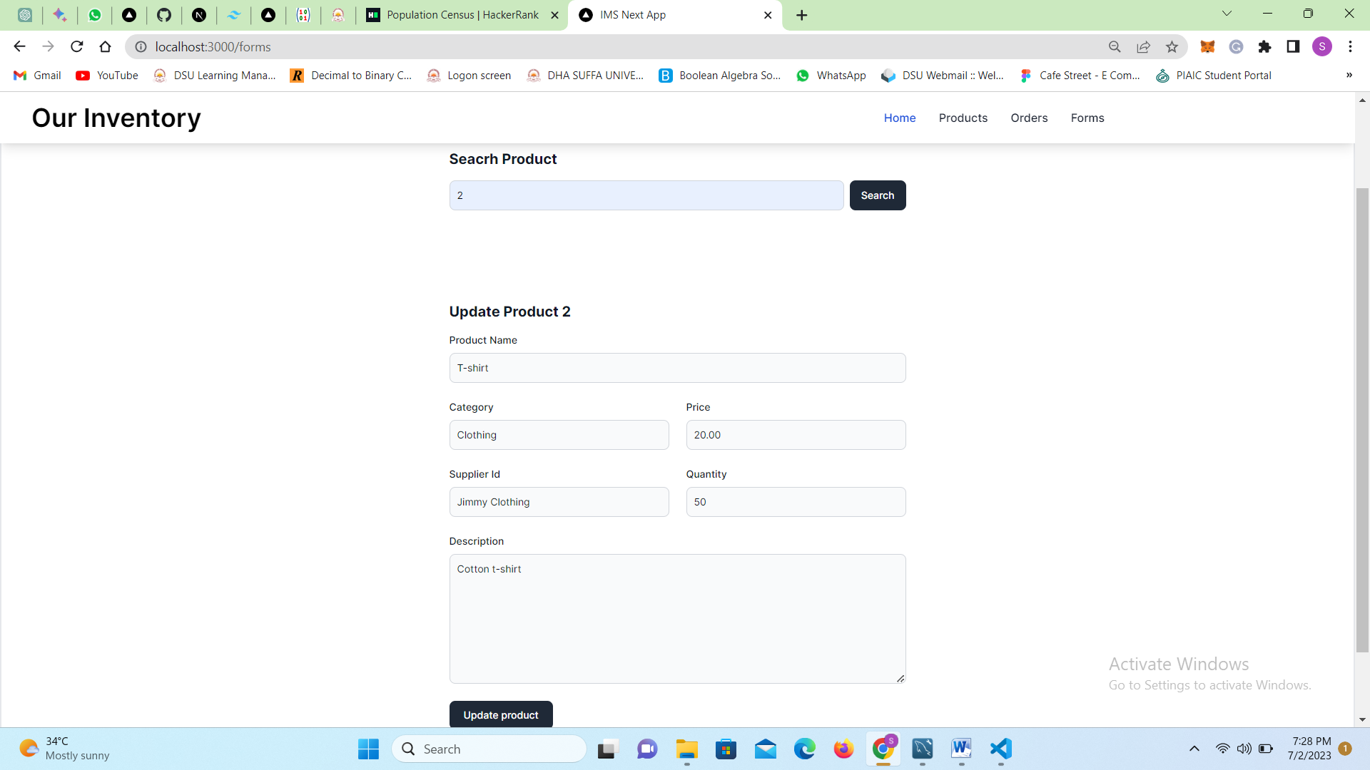

* Place Order Form

The "Place Order" form is a reusable component utilized on the forms page. This form initially prompts for the customer's name, determining whether the customer already exists in the inventory system. If the customer is already registered, the order is directly placed for them. However, if the customer is new, their details such as name, contact information, and address must be inserted before placing the order. The order details encompass the selected product, desired quantity, and the current date is automatically recorded upon data insertion. Through this process, an order is successfully placed.



